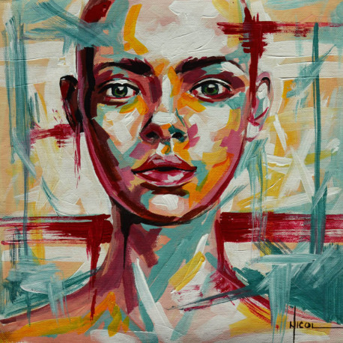

Given the opportunity to experience art, individuals will look at it from their own perspective and make their own personal connections. For this assignment, you need to extend that idea and select a piece of artwork that you feel best represents you. Once you have found a piece, please post it to the A#7 - Exploring Perspective discussion topic along with a detailed paragraph that explains your connection to that piece.
Please click here for a sample response from a student based on a painting by Raphael.
Consider one of the following websites to help you get started:
- Tate Modern
- Metropolitan Museum of Art
- Art Institute of Chicago

